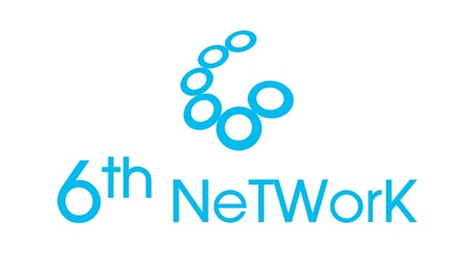

Press Release

Port of Antwerp selects 6th NeTWorK for automatic drones

The Antwerp Port Authority has selected the 6th NeTWorK consortium, a collaboration between DroneMatrix, Proximus and SkeyDrone, for the roll-out of a large-scale and innovative drone project.

D-Hive – operational drone capacity for the Port of Antwerp
In the framework of this project, called “D-Hive - Operational drone capacity for the Port of Antwerp”, a network of drones capable of performing automated flights from strategic locations in the port, is being developed. Via a unique platform, the Port Authority can draw up flight plans and routes remotely, set the purpose and desired output (photos, measurements, live stream, etc.) of the flight, and manage authorization requests.

The drones are deployed without manual intervention in the port to support its core processes and optimize overall operational excellence. This includes, for example, the detection of oil slicks and floating debris, infrastructure inspections, safety coordination, vessel traffic management support, calamity and incident support, site monitoring, environmental inspections and asset management.

Annick De Ridder, Antwerp Alderman responsible for the port: “The D-Hive innovative drone project makes Port of Antwerp the first port authority in the world to offer operational drone capacity on such a big scale. “A network of automatic drones that carry out flights at strategic places in the port offers considerable added value, in terms of security as well as efficiency. This demonstrates that we are giving concrete shape today to the smart port of tomorrow.”

The 6th NeTWorK consortium was founded at the end of 2020 by the hardware and software developer DroneMatrix, the telecom operator Proximus and the (drone) air traffic service provider SkeyDrone. Together, the three partners implement drone solutions from a service model in which drones can perform missions 'as a service' for business purposes and are also working together on the development of drone networks. The complementarity between the three parties enables the creation of a range of services fully geared to the demands of the market.

“The project is being carried out solely in support of the Port Authority,” says Frederik Winters, DroneMatrix project manager. “Based on the results, we want to inspire the port community to also use the Drone-as-a-Service (DAAS) model in the future. This concept takes care of all the concerns of companies and governments that rely on drone services. The technical aspect and permit applications are handled by us as the service provider, with the data and information made available to the user in real time.”

DroneMatrix, which is acting as the main contractor in the project, supplies both hardware and software for the drones. The company is also responsible for the operation of the flights. The company distinguishes itself through its in-house development of the technology used. According to Lander Vanwelkenhuyzen, General Manager of DroneMatrix, the quality of the technology and the operational approach have already been demonstrated in the Drones for Antwerp project. “Together with the city, the fire brigade and the police, we developed a number of applications - use cases - that served as the basis for the development of a well thought-out proposal for Port of Antwerp. However, a project like this, one of the largest European tenders for automated drones, is only feasible with the support of two strong partners: SkeyDrone and Proximus.”

Firmly established in the aviation landscape, SkeyDrone, as a subsidiary of skeyes and Brussels Airport Company, has the necessary expertise in house for this unique and large-scale project. “SkeyDrone will provide continuous monitoring of the operational ground and air risks. Integrating various static and dynamic data sources (such as position data from air traffic and ships) will enable us to determine the safest and most efficient flight routes. In addition, the flight authorization process will be further automated via our data platform, through integration with the UTM platform of our technology partner Unifly,” explained Hendrik-Jan Van Der Gucht, Managing Director of SkeyDrone.

Proximus, for its part, provides a state-of-the-art network infrastructure, delivers both cloud-based services for hosting the 6th NeTWorK platform and brings specific expertise in the field of IoT and analytics.
In March 2020, Proximus activated its 5G technology in the Port of Antwerp. Since then, the network has continued to evolve, and as a result most parts of the port area now enjoy coverage on the 3.5GHz spectrum. A high-performance mobile network like this, which can handle high speeds and reduce latency to a minimum, is not only crucial for the drones to function optimally, but also to ensure efficient data transfer. Consider, for example, how high-quality 4K live images can facilitate the coordination of safety and security in the port.

In this way, Proximus aims to contribute to a fertile digital ecosystem that promotes the development of innovative solutions through co-creation.
Anne-Sophie Lotgering, Enterprise Market Lead at Proximus: “Proximus has always been committed to developing the best gigabit network for Belgium, combined with the latest technologies. All of this comes together beautifully in this project: with our excellent network infrastructure and spirit of cooperation, we are contributing to the further expansion of the drone industry for the benefit of companies and giving an extra boost to innovation in the port.”

According to Lander Vanwelkenhuyzen, this project can undoubtedly become a springboard towards the future roll-out of similar innovative drone applications at other sites in Belgium and the rest of Europe.

Contact persons

POA
Lennart Verstappen
press@portofantwerp.com
+32 492 15 41 39

Proximus
Fabrice Gansbeke
press@proximus.com
+32 472 05 07 02

SkeyDrone
Didier Decaestecker
dde@skeydrone.aero
+32 475 94 92 84

DroneMatrix
Frederik Winters
frederik.w@dronematrix.eu
+32 498 97 33 43

Videolink
https://vimeo.com/675509574

